The Guide

One Two Zero
Operational carbon neutrality
Plannet Zero
2021

Starting your carbon journey is as easy as ...

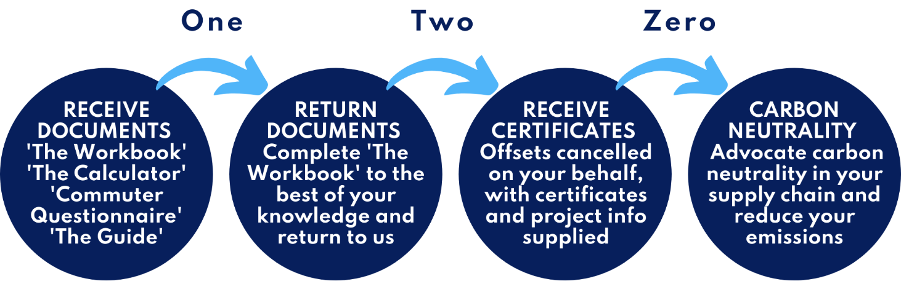

This Guide will help you to understand how to measure and report a company-level carbon footprint. Powered with the knowledge provided in this guide and the One Two Zero programme, you will be able to communicate your carbon footprint confidently and drive environmental action for your organisation.

The One Two Zero programme is the first of its kind and offers Small and Medium Enterprises (SMEs) affordable support and guidance so they can begin their net zero journey. The first barrier to most organisations is the high upfront cost of external carbon auditing, leading some businesses to take things into their own hands. This step-by-step guide eliminates wasted time and builds vital in-house knowledge and competence to deliver real change.

The Guide introduces the basic principles of carbon footprinting and the benefits to your organisation of operational carbon neutrality. As experts in the carbon market and with experience of working with many of Europe’s largest emitters, the Plannet Zero team have developed this product to help each business embark on its low carbon journey.

Background 3
Introduction 3

A guide to carbon emissions reporting 4
What is a carbon footprint? 4
Operational carbon footprint 4
Carbon dioxide equivalent 4
What are my sources of emissions? 5
Are there any reporting guidelines? 5
BSI PAS 2060 - declaring carbon neutrality 6
Defining your boundary 7

Carbon neutrality 8
What does carbon neutral mean? 8
Why go carbon neutral? 8
Carbon offsetting 8

One Two Zero 9
Footprint 9
Offset 9
Certify 10
Support 10

Why One Two Zero? 10

One Two Zero – our approach 11

Operational carbon neutral boundary 11

One Two Zero – a scope three solution 12

Best practice 13
Principles of self-validation 13
Communicating your message 13

Ongoing journey 14
Reducing year-on-year 14
Our promise to you 14
References 15

Background

Introduction

“Emissions of the anthropogenic greenhouse gases (GHG) that drive climate change and its impacts around the world are growing. According to climate scientists, global carbon dioxide emissions must be cut by as much as 85 percent below 2000 levels by 2050 to limit global mean temperature increase to 2 degrees Celsius above pre-industrial levels. Temperature rise above this level will produce increasingly unpredictable and dangerous impacts for people and ecosystems. As a result, the need to accelerate efforts to reduce anthropogenic GHG emissions is increasingly urgent. Existing government policies will not sufficiently solve the problem. Leadership and innovation from business is vital to making progress.” The Greenhouse Gas Protocol

There are direct benefits to organisations from measuring, reducing and reporting their greenhouse gas emissions. They will be able to action and plan activities and investments to reduce emissions, lower energy and resource costs, gain a better understanding of their exposure to the risks of climate change and demonstrate leadership, which will strengthen their green credentials in an increasingly environmentally-conscious marketplace. Already some organisations are asking suppliers about their greenhouse gas emissions. This will increase over time: many organisations and businesses will be expected to measure and report on their emissions to their customers and other stakeholders.

One Two Zero is a comprehensive service for operational carbon neutrality, moving ‘scope one‘ and ‘scope two‘ emissions towards net zero. If One Two Zero is taken up by your suppliers it has the added benefit of being a solution for supply chain emissions, your ‘scope three’ emissions. (See below ‘What are my sources of emissions?’) The One Two Zero service is designed to replace external sustainability consultants and guide you, with best practice, to complete a footprint compliant with internationally recognised methodologies. We help you understand how to identify and calculate your emissions. Upon receipt of your finished footprint calculation, we will retire carbon offsets on your behalf to cover your historic footprint for the year in question. We will return a carbon neutral certificate and information about the projects which your offset payments have supported. We will provide marketing information and a carbon neutral stamp, that you can use with emissions data in your reporting, enabling you to communicate confidently with your stakeholders and set a course for net zero.

Fig 1: Key steps in calculating an organisation’s carbon footprint
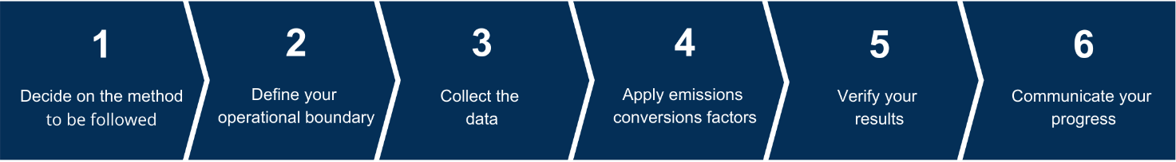

A guide to carbon emissions reporting

What is a carbon footprint?
A carbon footprint is the measurement of the total greenhouse gas emissions released directly and indirectly from the activities of an individual, company or organisation or for a specific product or service.
Carbon footprints enable you to identify and quantify your key sources of emissions and understand how you contribute to global emissions. This will help to pinpoint the opportunities to reduce carbon emissions within your organisation, allowing you to plan and implement carbon reduction plans, reduce emissions from current and future activities and monitor your progress.

Operational carbon footprint
An operational carbon footprint measures the greenhouse gas emissions from all the direct and indirect operational activities of the organisation. This includes electricity and other fuel used in buildings, industrial processes and fuel used in company-owned vehicles (scope one emissions). It also includes some scope three emissions, such as business travel, employee commuting, waste management and water supply.

Supply chain footprint

A supply chain footprint measures the greenhouse gas emissions released within the supply chain due to the activities of the reporting organisation. These are often referred to as the reporting organisation’s scope three emissions.

The reporting organisation may choose to focus only on its upstream emissions (‘cradle to gate’) or its entire value chain (‘cradle to grave’).

Product or service carbon footprint
A product carbon footprint measures the greenhouse gas emissions over the whole life of a product or service, from the extraction of raw materials and manufacturing, through to emissions associated with the use and end-of-life of a particular product. This is sometimes known as ‘cradle to grave’ or full life cycle analysis.

Carbon dioxide equivalent
A carbon footprint is measured in units of carbon dioxide equivalent (CO₂e), which enables various greenhouse gases to be reported on a like-for-like basis. A carbon footprint accounts for all six greenhouse gas emissions that are regulated under the Kyoto Protocol of the United Nations Framework Convention on Climate Change:
- Carbon dioxide (CO₂)
- Methane (CH₄)
- Nitrous oxide (N₂O)
- Hydrofluorocarbons (HFCs)
- Perfluorocarbons (PFCs)
- Sulphur hexafluoride (SF₆)
Whilst carbon dioxide is the least damaging of these gases on a per tonne basis, it is by far the most abundant and as a result, when reporting, CO₂e is used and typically will be preceded with a weight in either tonnes (t) or kilograms (kg). Five other gases are converted to tCO₂e by their ‘global warming potential’, which have been agreed internationally.

What are my sources of emissions?

Emissions occur principally from the burning of fossil fuels for energy, gas leaks from industrial processes or equipment (such as refrigeration and air conditioning) and from chemical reactions. In the great majority of cases, the closer your organisation is to the actual emissions released, the easier it is to quantify, measure and reduce those emissions. Greenhouse gas emissions have been arranged into three groups or ‘scopes’, based on their proximity to an organisation’s core activities:

Scope one: direct – fuel burned in an organisation’s vehicles, generators, machinery and buildings.
Scope two: indirect energy – emissions from purchase and use of electricity, steam, heating and cooling.
Scope three: indirect value chain – any other emissions an organisation causes to be released based on purchased goods and services and produced goods and services.

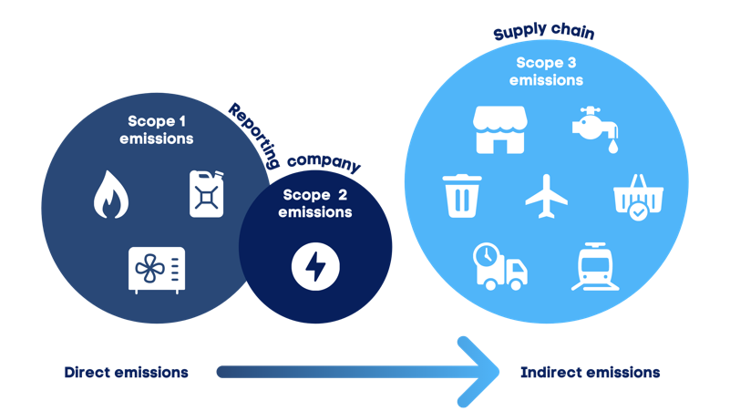
Fig 3: Overview of scope one, two and three emissions

Are there any reporting guidelines?

The GHG Protocol Corporate Reporting and Accounting Standard developed by the World Resources Institute is the most widely used and internationally-recognised standard for corporate footprinting of greenhouse gas emissions.
In the UK, the Department for Environment, Food and Rural Affairs (DEFRA) publishes annual emissions conversion factors and general guidance principles to help UK businesses and organisations measure and report greenhouse gas emissions.
As this is UK specific, this is the best guidance to use for UK-based organisations and is based on the principles set out by the GHG Protocol Corporate Reporting and Accounting Standard. Our One Two Zero programme uses the very latest 2020 DEFRA conversion factors and the principles of both national and international standards for the most comprehensive reporting.
Under the 2013 DEFRA reporting guidelines and GHG Protocol Corporate Reporting and Accounting Standard, company footprints must include scope one and scope two emissions. There is more flexibility when choosing which scope three emissions to measure and report, and you can tailor this, transparently, to reflect your environmental and commercial strategy and goals.
Your approach is likely to depend on what data is readily available, what time and budget you have for footprinting, what you intend to use the footprint for, what you would like to monitor and where you can make the biggest reductions. Organisations commonly include waste sent to landfill, water usage and employee business travel; all scope three emissions, traceable by the reporting company. Including these emissions along with scope one and two is referred to as an organisation’s ‘operational emissions’.

BSI PAS 2060 - declaring carbon neutrality

The British Standards Institution has set out its own internationally-applicable specification for demonstrating carbon neutrality. This is a robust and well-adopted methodology for carbon neutrality and has the additional requirements of a strategic approach to annual reductions and effective climate change mitigation measures. Plannet Zero follows this advice and has created the One Two Zero programme to give organisations expert guidance on their low carbon strategy and confidence in declaring operational carbon neutrality along the way.

PAS 2060 allows for offsetting to be undertaken, based on historical activities during the reporting year. The graphic below from PAS 2060 explains how offsetting can be used alongside a carbon reduction strategy for organisations looking to achieve carbon neutrality.

Fig 4: Demonstrating of carbon neutrality, PAS 2060 pathway number 3.

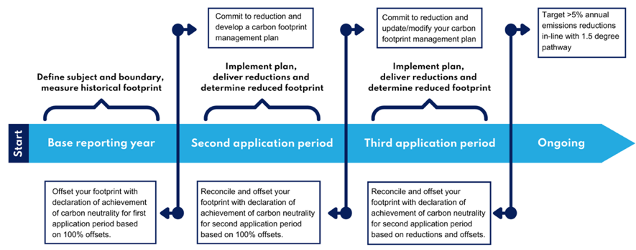

Defining your boundary
Set a clear and realistic boundary around what is and is not included in your reporting. A boundary determines which emission sources will be quantified. An operational boundary includes the full range of emissions from activities under your operational control, all scope one and two emissions and those scope three emissions caused directly by your operations and actions, for example commuting, waste and water usage.
For some organisations, emissions within scope three may be the largest proportion of total emissions. Calculating your scope three emissions, gives a more complete understanding of your organisation’s total impact on climate change. However, it is acknowledged that scope three emissions can be difficult to measure and calculate. One Two Zero has been designed to address this and focuses on operational carbon neutrality which includes the operational scope three emissions, within your reporting boundary.
DEFRA recommendation: Measure or calculate emissions that fall into your scopes one and two.
Discretionary: Measure or calculate significant scope three emissions in addition to scopes one and two.

Fig 5: The One Two Zero boundary of reporting
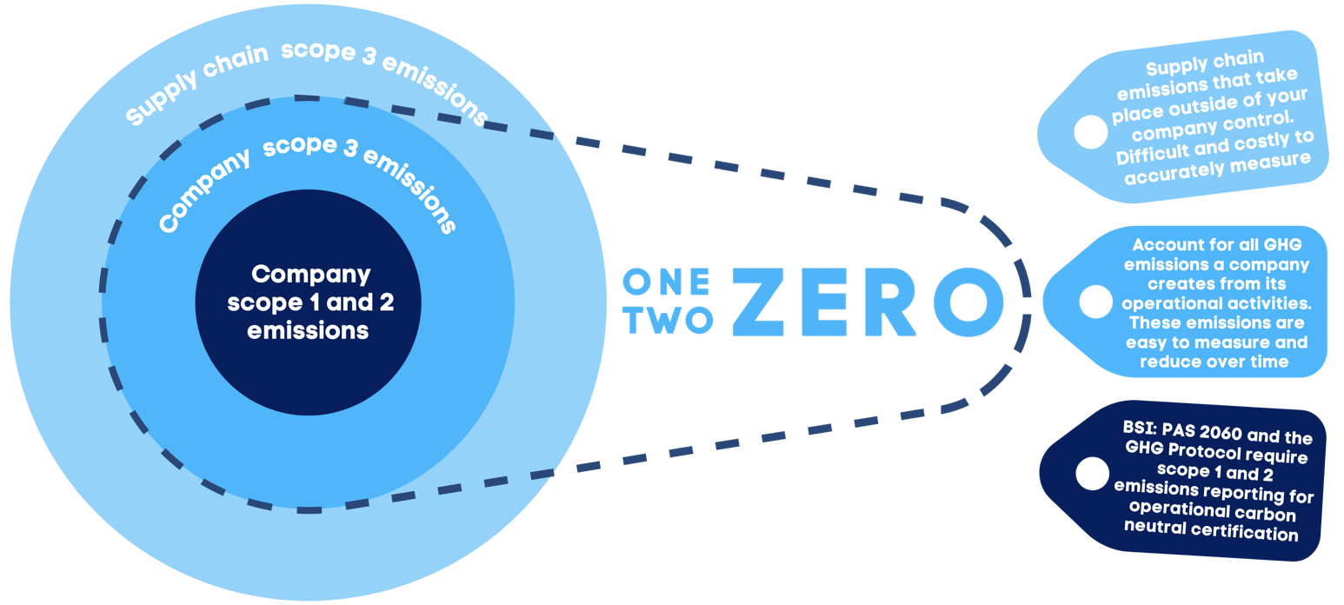

Carbon neutrality

What does carbon neutral mean?

Key to moving to carbon neutrality is to reduce emissions as much as possible. However, when a strategy is in place, there are often some emissions which cannot (maybe at this point in time) be eliminated. ‘Carbon neutral’ is a term given to activities, such as a service, product, event or total activities of an organisation, where emissions are reduced and the residual greenhouse gas emissions caused by the organisation or activity have been balanced by funding an equivalent amount of greenhouse gas emissions being avoided or removed somewhere else.

These externally verified emission reductions, also called carbon credits or carbon offsets, are generated through helping to fund nature-based, renewable energy and energy efficiency projects, many of which bring additional social and community benefits as well as avoiding or removing greenhouse gases.

Why go carbon neutral?

Carbon neutral programmes play a vital role in accelerating the global transition towards net zero by enabling organisations to take responsibility for their greenhouse gas emissions today, whilst they plan and deliver longer-term changes.

There are an increasing number of organisations claiming to be carbon neutral. They recognise that being carbon neutral can play a key part of their sustainability and Corporate and Social Responsibility (CSR) strategy whilst enabling them to act responsibly and contribute towards addressing global climate change. They also realise that individuals and corporate customers increasingly prefer to buy products and service from environmentally conscious suppliers.

Carbon offsetting

Carbon offsetting is the process of buying and retiring carbon credits equivalent to your carbon footprint. As one unit of CO₂e has the same climate impact wherever it is emitted, the benefit to addressing climate change is the same wherever it is reduced or avoided. There is a plethora of different offset projects, creating carbon credits across the globe. Offsets can vary in price based on the project them come from and the volume of offsets available and bought. Project type, location and the additional social, community and biodiversity benefits can all affect attractiveness to different buyers and so affect price.

Carbon offsets can be divided into two groups:

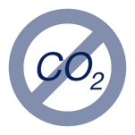
Avoidance – Carbon avoidance entails financing projects that avoid the emission of greenhouse gases. Such projects include forest conservation, recovering and using biogas, replacing inefficient cookstoves or ways of cooking with less polluting ones, waste management and recycling and investments in energy efficiency.

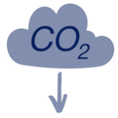
Removals – Carbon removals involve removing greenhouse gases from the atmosphere and can be achieved in a range of ways, for example through nature-based solutions, such as reforestation and soil carbon sequestration, or using technological solutions, such as direct air carbon capture and storage.

The difference between carbon neutral and net zero offsetting: both avoidance and removal offsets can be used to achieve carbon neutrality whereas only removal offsets can be used in net zero claims.

One Two Zero
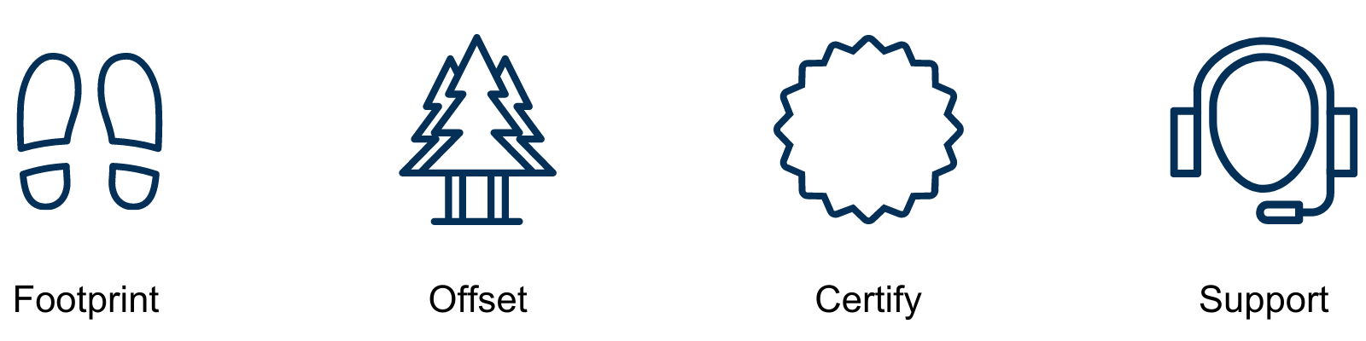
One Two Zero is a turnkey solution for SMEs that want to make a planet-friendly impact. Plannet Zero’s One Two Zero package allows your organisation to confidently account for all its operational greenhouse emissions, offset these emissions, become operational carbon neutral and receive ongoing support to help you reduce future emissions.

Footprint

We have put together a set of footprinting documents that go along with this guide to make calculating your carbon footprint as easy as possible. These documents will help guide you towards information and data that is likely to be readily-available and accessible within your organisation. We anticipate it will empower your teams to identify your operational emissions and potential reductions. This self-validated exercise will help to start your carbon management system, highlight your most carbon-intensive operations and encourage you to implement carbon reduction policies where possible. It will enable and empower you to learn and over time have the confidence to become in-house advocates of your organisation’s net zero journey. It is likely to engage employees, including encouraging them to think about the emissions from their journeys to work.

Footprint documents include:

- The Workbook – Word
- The Calculator – Excel
- Employee Commuting Questionnaire – Word/SurveyMonkey

Offset

We use high-quality carbon offset projects to balance the residual emissions of every One Two Zero customer. A two-project blend of offsets from a Gold Standard wind project and a Verra CCBA forestry project has been selected to mix biodiversity protection and restoration with fuel switching to renewable energy. Carbon credits will be retired as part of the service and are included in the overall cost.

Along with working with you, to ensure your calculations are as accurate as possible, Plannet Zero will retire, on your behalf, a volume of offsets equivalent to 110 percent of your footprint to give an extra buffer of assurance.

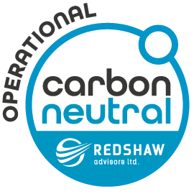
Certify

Redshaw Advisors Ltd, an award-winning environmental market consultancy and Plannet Zero’s parent, will authenticate your carbon footprint and your organisation’s operational carbon neutrally claim for the specified reporting year. You will be sent a certificate of carbon neutrality, badges to use on products and company literature and information on the two projects that have provided the retired offsets to balance your organisation’s footprint, all of which you can use in marketing and annual reports.

Support

After completing your first steps in your low carbon journey we will work with you as you improve your environmental performance, reduce your climate impact and align yourself with a net zero strategy. We will become your retained sustainability partners offering you advice and guidance on all these matters, whenever needed. We will keep you abreast of legislative change, supply and demand dynamics, renewable energy switching and assist you with any future offsetting needs. Our support comes in the form of:

- Final emissions report
- Assistance producing your Qualifying Explanatory Statement to be in-line with BSI PAS 2060
- Ongoing support – dedicated account manager
- MonthlyRed – market news service
- Bi-annual review – consultation

Why One Two Zero?

A standard you can trust – Based on internationally-recognised guidance, The GHG Protocol Corporate Reporting and Accounting Standard and BSI PAS 2060, One Two Zero goes beyond requirements for standard organisational reporting. We work with you to achieve a premium certification of operational carbon neutrality.

A comprehensive operational carbon neutral programme – One Two Zero distinguishes itself from most operational footprinting programmes by including company scope three emissions to give the clearest picture of your organisation’s emissions and opportunities for reductions.

A credible, accessible solution for full supply chain neutrality – Designed for SMEs, One Two Zero has been created to be affordable, accessible and efficient. It has a robust, clear reporting boundary and yet is a compelling drop in solution to green your whole supply chain: if each supplier goes operational carbon neutral, they each address the emissions that they emit, meaning each emitter addresses their own footprint: the responsibility, actions to reduce emissions and the costs are shared down the supply chain. In this cascade, where each business takes responsibility for its own scope one and two emissions, scope three emissions disappear.

Trusted high-impact projects – We have a deep knowledge and understanding of the voluntary carbon market, gathering and performing regular due diligence including satellite monitoring, on our projects. You can be safe in the knowledge that you are supporting the highest quality projects in the market.

Ongoing support and carbon management – We will continue to guide and educate you through future years’ reporting, reduction strategies and market dynamics.

Affordably-priced – One Two Zero has been designed for you to create a robust low carbon strategy effectively and efficiently, supported by expert guidance and offset procurement.

One Two Zero – our approach

One Two Zero is based on the principles of organisational carbon neutrality set out by the GHG Protocol Corporate Reporting and Accounting Standard and BSI PAS 2060, where companies are required to report their scope one and scope two emissions. In order to provide added accountability and footprint transparency, we have identified a set of company scope three emissions that all organisations can identify, measure and affect. These emissions are created as a direct result of the day-to-day operations of an organisation and so we believe it is responsible to include them within the boundary of reporting.

To determine which emissions are significant, DEFRA recommends that organisations initially focus on scale and then use the remaining three criteria:

- Importance to your organisation
- Importance to stakeholders
- Potential for reductions.

Based on these principles, One Two Zero includes transport, waste and water-related emissions within the operational footprinting boundary.

Operational carbon neutral boundary

If you can’t measure it, you can’t reduce it
Understanding all the emissions your organisation is responsible for and creating an effective boundary of reporting creates a robust and comprehensive footprint for your organisation. By including all the significant scope three emissions that contribute to day-to-day operations, your organisation reaches the most comprehensive understanding of emissions it can control. If you are unable to accurately measure emissions, for example emissions related to the production of printer toner that is purchased from a supplier, then it is likely that you are unable to reduce them. You could try and find a new supplier that produces a carbon neutral toner; this might be possible. However, for a large supply chain such choices might be overwhelming or not available – or, for either reason, not possible immediately. You could attempt a potentially expensive exercise to estimate your supply chain emissions. However, the emissions related to the production of the toner, or other supply chain products and offerings, belong to that particular supplier; the supplier has the necessary data available to accurately footprint its production and, importantly, has control over reducing that footprint. Advocating carbon footprinting and neutrality to your supplier is a responsible route forward. This way your supply chain becomes more transparent as a whole, change can happen most efficiently, the costs are spread and all businesses start their net zero journey, working towards becoming more sustainable.

Fig 6. Company scope three emissions - our operational boundary
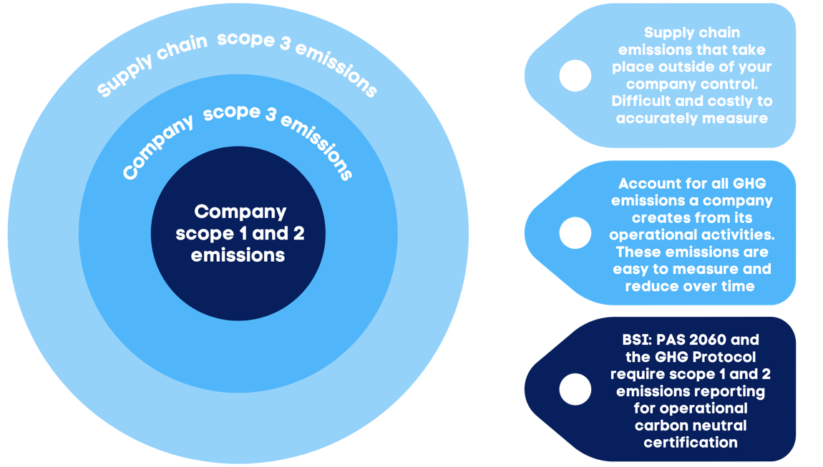

One Two Zero – a scope three solution
By calculating all the emissions that fall within the One Two Zero boundary, an organisation is able to get an extremely accurate measurement of its operational footprint without having to make estimates of supply chain impacts. Instead, One Two Zero becomes a solution to these wider scope three emissions by the uptake of the programme in your supplier network. We hope and anticipate you will find One Two Zero cost-efficient and easy-to-use and that it will be a product that you can endorse to your whole supply chain, to encourage a more sustainable way of operating, share the benefits of carbon neutrality and spread the associated costs, based on where the emissions occur and can be best addressed.

Fig 7. One Two Zero as a cost-effective solution for supply chain carbon neutrality
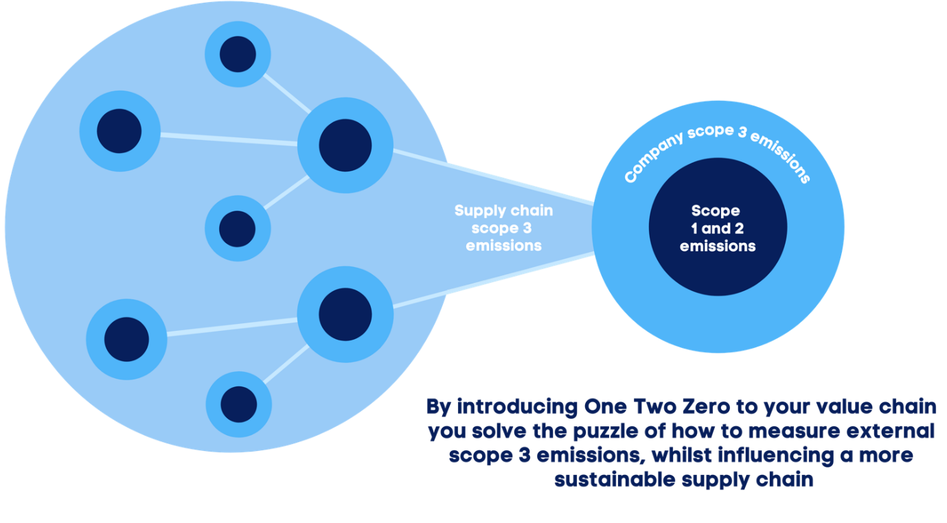

Best practice

Principles of self-validation

Self-validation has a number of benefits to external auditing of a corporate footprint: it is a far more cost-efficient process; it embeds a culture of monitoring and reporting within the business; allows reduction opportunities to be more easily seized; and often data can be collected and used more efficiently.

The World Resources Institute, a leading centre for policy research and analysis, addressing global resource and environmental issues, describes five key principles of greenhouse gas reporting:

Relevance: Ensure the GHG emissions you report appropriately reflect the emissions of your organisation and serves the decision-making needs of users – both internal and external to the organisation.

Completeness: Measure and report on all GHG emissions sources and activities from the businesses / operations for which you are collecting GHG data. Disclose and justify any specific exclusions.

Consistency: Use consistent methodologies to allow for meaningful comparisons of emissions over time. Transparently document any changes to the data, changes in your organisational boundary, methods, or any other relevant factors.

Transparency: Address all relevant issues in a factual and coherent manner, keeping a record of all assumptions, calculations, and methodologies used. Report on any relevant assumptions and make appropriate references to the accounting and calculation methodologies and data sources used.

Accuracy: As far as can be judged, ensure that your reported GHG emissions data is systematically neither over nor under your actual emissions. Seek to reduce uncertainties in your reported GHG emissions where practical. Achieve sufficient accuracy to enable users to make decisions with reasonable assurance as to the integrity of the reported information.

Communicating your message

Many organisations choosing to take planet-friendly action access the voluntary carbon market. There are standards and bodies that issue guidance, but the industry is as yet unregulated. That said, in the UK the Advertising Standards Agency issued over 200 fines for the improper use messaging around carbon neutrality in 2020. Acts of over-claiming or falsely declaring environmental efforts in the pursuit of a marketing advantage has become known as ‘greenwashing’. The best way to avoid these claims is to be transparent with your audience on all the steps your organisation has taken. Describing fully your organisation’s experience, is the best way to bring your customers along with you on the journey. One added benefit of the One Two Zero programme is the operational boundary that we have established, this term makes it clear to your audience what has been included in your carbon footprint.

Ongoing journey

Using the documents to form your annual environmental management and reduction plans will set your organisation on course to achieve net zero by 2050 – potentially years earlier. Creating a firm boundary of reporting and empowering in-house environmental advocates will mitigate future emissions-related risks and enable your organisation to appreciate and capitalise on – and in some cases innovate and anticipate – new opportunities that come with a low carbon future.

Reducing year-on-year

We encourage all our One Two Zero clients to set a minimum five percent emissions reduction year-on-year in order to align their businesses with the Paris agreement that hopes to limit the worst effects of climate change and keep us on track for >1.5º global temperature rise by 2050.

We ask that the five percent emissions reduction be demonstrated in order to continue benefitting from operational carbon neutral status in future reporting periods. However, the reductions do not need to be displayed based on absolute footprint and can be demonstrated by unit of production, by number of employees or relative to turnover to allow for business growth. It might also be that there are reasons why the reduction path is stepped over time, rather than having a smooth reduction gradient or rate. Whilst we would not be prescriptive about your business, we would like to suggest this ambition.

In-line with PAS 2060 guidelines you are required to produce a Qualifying Explanatory Statement (QES) The QES explains the (definition of QES). Plannet Zero provides support in communicating your QES and will keep you on track with regular check-ups to help you achieve your targets.

Our promise to you

Plannet Zero will help all One Two Zero clients with expert advice and guidance but the reductions can only be made if every organisation looks at where and how it can make climate-benefiting reductions.

One Two Zero will empower one or more in-house sustainability champions to drive environmental action for your organisation. Plannet Zero will be your retained expertise and we are readily available to discuss best practice, data, terminology, promotional help and many other issues that are likely to arise along the way.

After the initial measuring, calculating, verifying and retiring of offsets, we will make a point of being in touch around four and eight months into your programme to make sure you feel you are on track and understand the emissions from your activities. We look forward to hearing how the information gathering has helped shape policy and will help wherever possible.

The One Two Zero programme will equip your organisation for environmental reporting and bring the associated Key Performance Indicators (KPIs) to boardroom level, in advance of Government requirements.

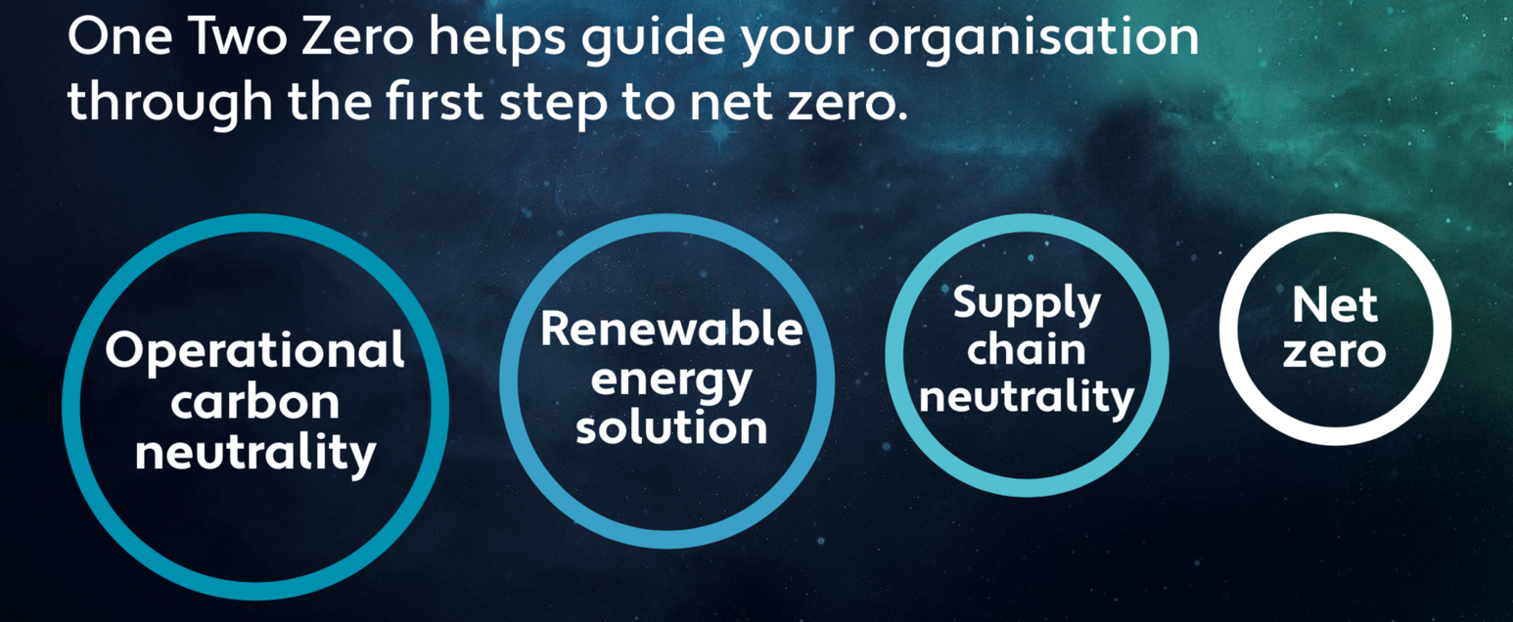

Next Steps

- Switching to renewable energy – one of the biggest ways to reduce your organisation’s carbon footprint is to switch to electricity sourced from renewable energy. There are a number of different solutions available including green tariffs, Renewable Energy Certificates, Power Purchase Agreements and installing on-site renewable power. The Plannet Zero team would be happy to discuss what could be the appropriate solution for your organisation.

- Engaging your supply chain – a key action you could take to reduce your wider climate impact is to engage and work with your supply chain, both up and downstream, to work towards full scope three transparency. Advocating an operational carbon neutral boundary to all your key suppliers creates a robust level of data and a community of environmental action to accelerate reductions and shares the financial cost.

- A net zero target – armed with your carbon footprint and understanding carbon neutrality, you may wish to set a net zero target for your organisation. Setting a net zero target is the future for all organisations as, in the UK, for example, we have been conscripted to a net zero 2050 target by Government. Many businesses have brought their targets forward by ten or 20 years. Plannet Zero will help you to understand how to reach net zero and set realistic and achievable targets along the journey.

References
- Intergovernmental Panel on Climate Change (IPCC), Global warming of 1.5º Summary for Policymakers, 2018.
- Greenhouse Gas Protocol, Corporate Value Chain (Scope 3) Accounting and Reporting Standard Supplement to the GHG Protocol Corporate Accounting and Reporting, 2011, p3.
- United Nations, Kyoto Protocol to the United Nations Framework Convention on Climate Change: Annex A, 10 Dec 1997, pp.22-23.
- Greenhouse Gas Protocol, The GHG Protocol Corporate Accounting and Reporting Standard revised edition 2015.
- HM Government, Environmental Reporting Guidelines: Including streamlined energy and carbon reporting guidance, (updated) March 2019.
- DEFRA, Guidance on how to measure and report your greenhouse gas emissions, 2009.
- DEFRA, Conversion factors 2020: full set (for advanced users), 9 June 2020.
- BSI, PAS 2060:2010 Specification for the demonstration of carbon neutrality, 2010.
- DEFRA, Small Business User Guide: Guidance on how to measure and report your greenhouse gas emissions, 2013.

Greenhouse Gas Protocol, Corporate Value Chain (Scope 3) Accounting and Reporting Standard Supplement to the GHG Protocol Corporate Accounting and Reporting, 2011, p3.
UN "Kyoto Protocol to the United Nations Framework Convention on Climate Change: Annex A". United Nations Framework Convention on Climate Change. (10 Dec 1997) p.22-23
Greenhouse Gas Protocol. “The GHG Protocol Corporate Accounting and Reporting Standard” revised edition (2015).
DEFRA “Conversion factors 2020: full set (for advanced users)” (9th June 2020)
DEFRA “Guidance on how to measure and report your greenhouse gas emissions” (2009)
Adapted image from BSI PAS 2060:2010 ‘Specification for the demonstration of carbon neutrality’ Figure 3 - Illustration of the requirements for demonstrating carbon neutrality – using first year offsetting concession to achieve carbon neutrality for the first application period, 2010, p.8.
DEFRA “Guidance on how to measure and report your greenhouse gas emissions” (2009) p.49
Drawn from accounting principles and the internationally-recognised Greenhouse Gas Protocol Corporate Accounting and Reporting Standard from the World Resources Institute, known as the ‘GHG Protocol Corporate Standard’.
Listed in the order they are first referred to in the document above.

