LOC HOT BRIEF
Confidential to Optical Contractors & Performers • June 2018 • Issue 72

LOCs are asked to circulate this Hot Brief to all contractors and performers in their area as soon as possible.

How to submit 2018 CET claims
A new process for submitting 2018 CET claims has been agreed with PCSE to ensure claims are processed and paid in a timely fashion. The window for submitting 2018 CET claims is 2 July 2018 to 1 November 2018 and the allowance is £551.
Please remember, CET claims can only be submitted by and paid to contractors.
To submit a CET claim, please follow these steps:
- Complete the 2018 CET claim form issued by the Department of Health in full - a guide to completing the CET claim form can be found on the LOCSU website
2. Scan or take a clear and well-centred photograph of the signed form.
3. Open the ‘Enquiries form’ on the Contact Us page on the PCSE website and select ‘CET Claim’ as the ‘type of enquiry’ from the drop-down menu (see below).
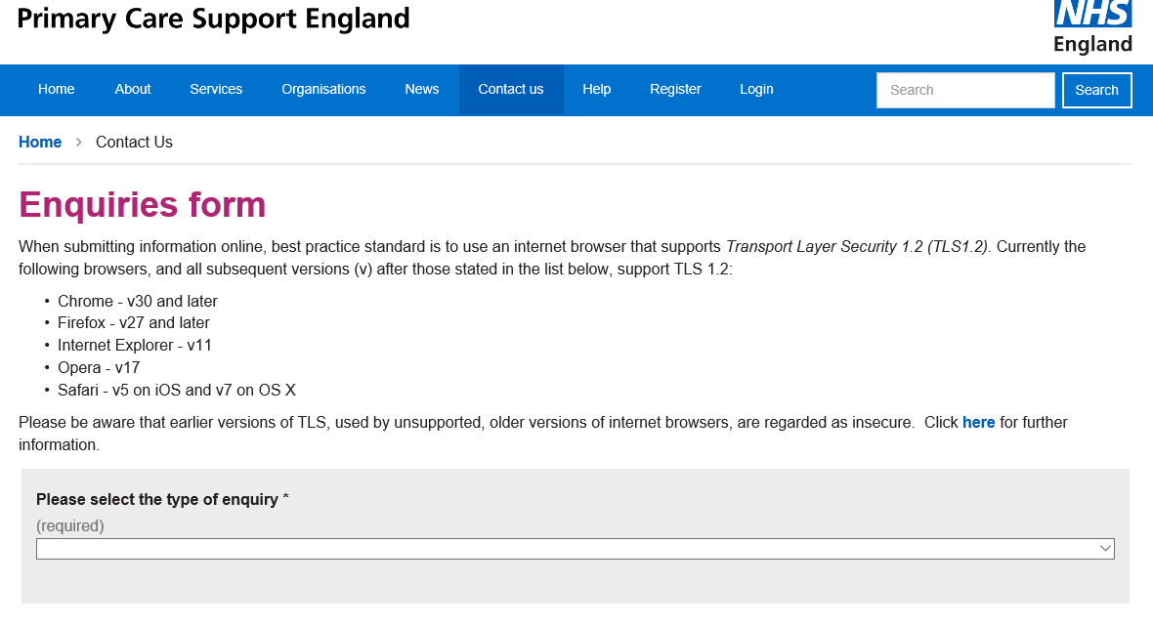
4. Click ‘begin’ on the CET landing page (see below)
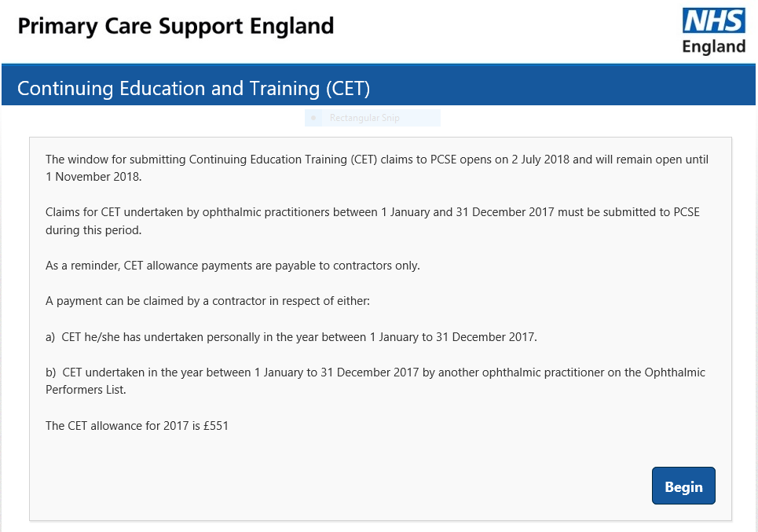
5. Click ‘No’ to confirm that a 2018 CET claim has not been previously submitted for the Performer (see below)
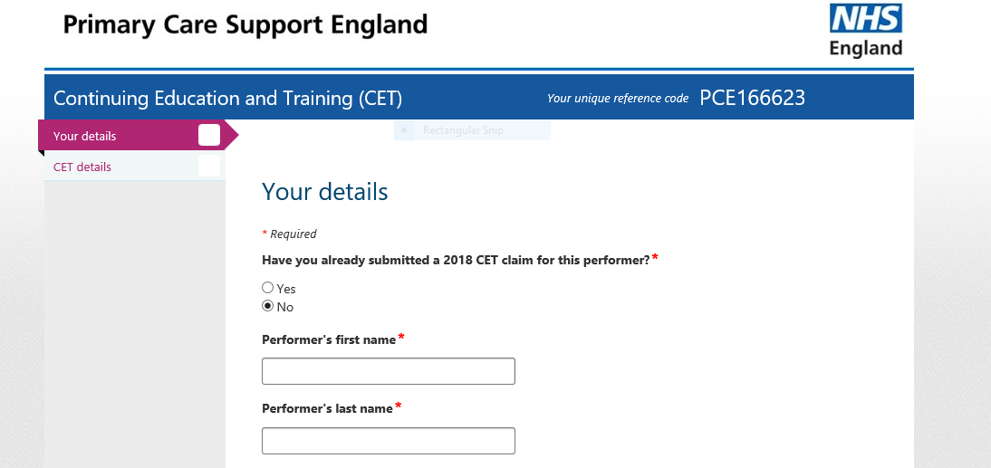

6. Complete all the mandatory fields on the ‘Enquiries form’:
- Name of the performer the CET grant is being claimed for
- Name of the practice contact submitting the form and practice email address registered with PCSE
- ODS code (also known as TP code) – if you do not know the ODS code for your practice you should contact the Exeter Helpdesk on 0300 3034 034 or E-mail: exeter.helpdesk@nhs.net
- PCT code*
- Contractor code*
* The PCT code and Contractor code (payment system code) can be found in the two boxes in the top right corner of your GOS submission headers e.g. 5C5 121.
7. Upload the signed claim form (either as a single document or as three separate pages).
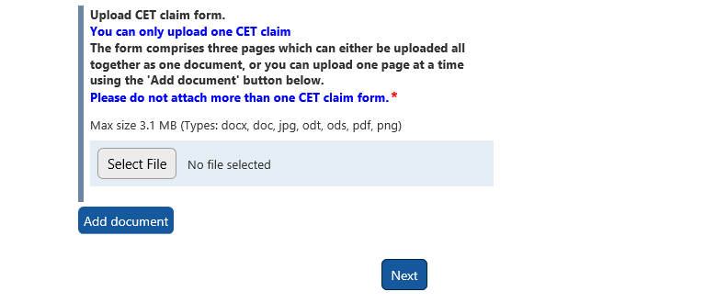

8 Once the claim form has been uploaded, click “Next”.
9. A pop-up screen will appear to confirm the submission has been successful and provide a case reference number which will include the name of the performer the claim form relates to (e.g. CAS-12345-ABC123 CET PERFORMER NAME).
The case reference number will also be sent in a follow-up email to the practice to confirm the claim form has been received by PCSE and should be quoted in any subsequent correspondence regarding the claim.

10. Once the CET claim has been processed, the practice will receive an email confirming the case has been closed and the CET grant will be paid in the next GOS payment run.
Due to restrictions on the existing Ophthalmic Payments System, the CET payment will appear on the contractor’s GOS statement as Enhanced Service Value. Details of the name of the performer that the CET grant is for will be included.
The recommended route for submitting CET claims is online as described above but if you prefer to submit by post you can send to:
Primary Care Support England
PO Box 350
Darlington DL1 9QN
If you are sending a CET claim by post, please send it separately to your GOS claims to ensure it is processed promptly.
2018 Claim forms submitted by email or sent to any other postal addresses will not be processed.
All 2017 CET claims should now have been paid. Queries regarding unpaid 2017 CET claims should be directed to info@locsu.co.uk so that they can be escalated.
Any LOC requiring advice / support on any aspect of their work should contact LOCSU on 020 7549 2051 or email info@locsu.co.uk

